# National Survey of Victimization of Companies (ENVE) 2018

<https://www.inegi.org.mx/programas/enve/2018/default.html#Tabulados>

<https://www.inegi.org.mx/programas/enve/2018/>

Spending on measures to protect from crime & Losses as a result of crime

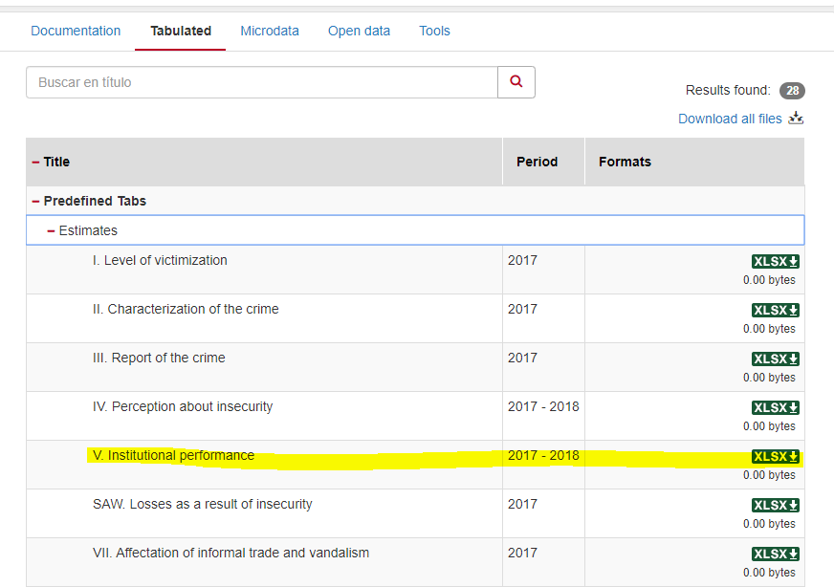

# Incarceration

<https://www.inegi.org.mx/programas/cngspspe/2019/default.html#Tabulados>

Download prison system download and take tab 3.3

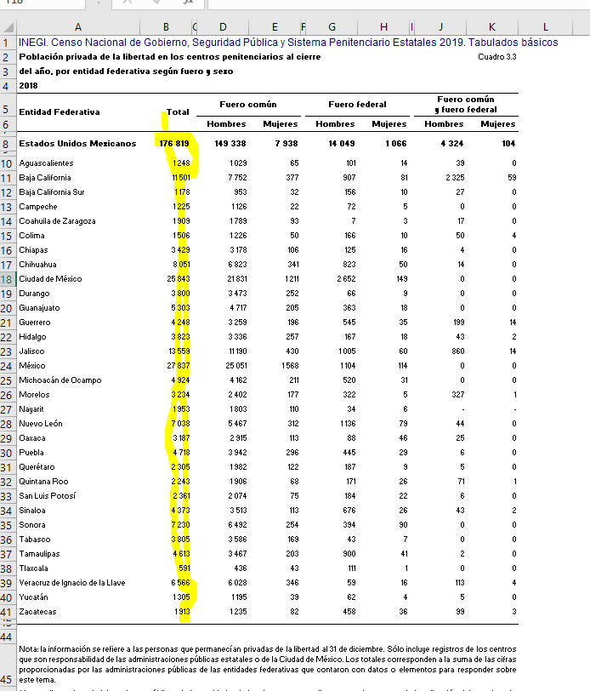

# Minimum wage:

<https://datos.gob.mx/busca/dataset/listado-de-salarios-minimos-generales-establecidos-para-la-republica-mexicana>

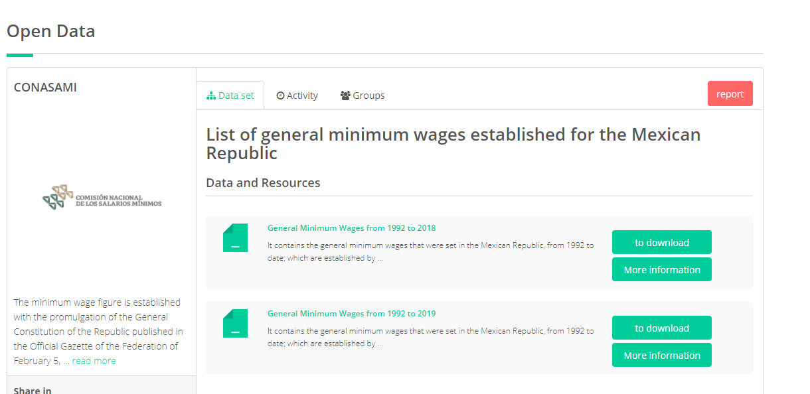

# Encuesta Nacional de Victimización y Percepción sobre Seguridad Pública (ENVIPE) 2018

<https://www.inegi.org.mx/programas/envipe/2019/>

<https://www.inegi.org.mx/programas/envipe/2018/default.html>

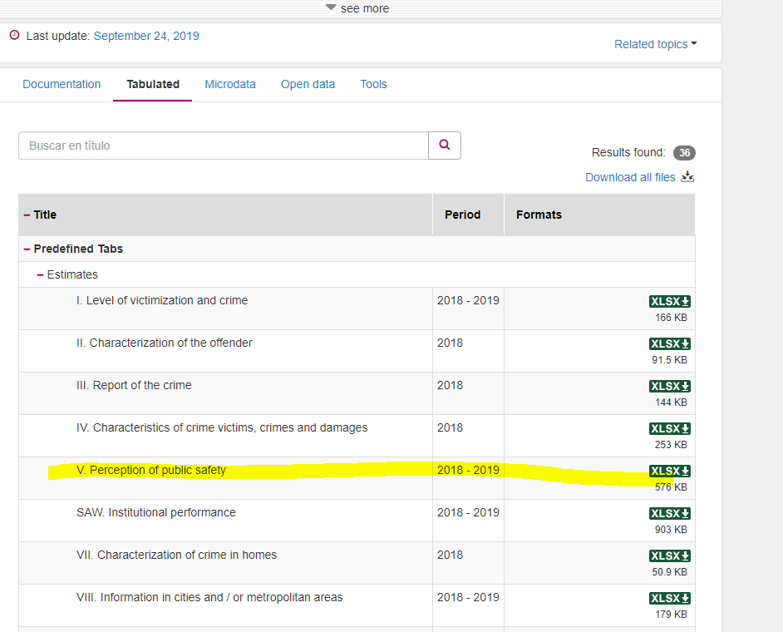

Tab 5.7

# GDP

<https://www.inegi.org.mx/temas/pib/>

<https://www.inegi.org.mx/temas/pib/default.html#Tabulados>

<http://en.www.inegi.org.mx/datos/?t=0190000000000000>

# Budgetary Expenditure and FASP

<http://presto.hacienda.gob.mx/EstoporLayout/estadisticas.jsp>

